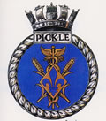
HMS PICKLE
Courage grows under difficulty

Discipline
The following infringements are considered to be chargeable offences under the PICKLE NIGHT DISCIPLINE ACT.
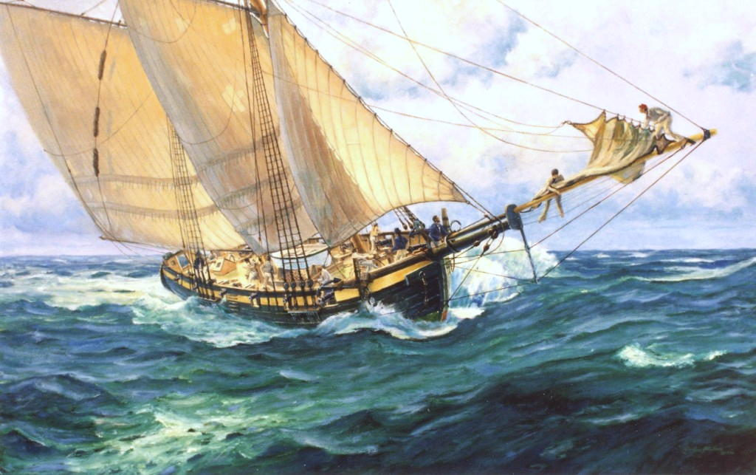
1. Failure to muster on the Gun Deck when called to dinner
2. Standing when thou shouldest be sitting
3. Sitting when thou shouldest be standing
4. Indulging in games or gambling which have no approval (QRRN)
5. Unlawful waste of thy daily victuals by casting on thyne shipmates
6. Blatant disregard for thyne morale by failing to fully consume thyne Grog Ration
7. Participating in Raleigh’s Tickler (Tobacco) or Lamp Lighters Oil (Vaping) without the President’s approval
8. Leaving the Gun Deck unless doubting your soul in great peril
9. Failing to fill thine glass from the port receptacle.
10. Eddying the port against the tidal flow
11. Heckling or Barracking the speakers while they art orating
12. Not taking in the merriment of the occasion
13. Sailors shalt treat thy Wenches in true Naval fashion
14. Wenches shalt treat thy Sailors in true Naval fashion
15. Conduct deemed by the President to besmirch the good name of HMS Pickle
15. The use of any mechanical devices deemed to be “Satan’s Technology”

Transgressors will be fined “Pieces of 8” which will be Passed as Alms to a deserving cause

<Insert name here>
PRESIDENT

Ship’s Routine for <insert date here>

0430 Cook to the Galley
0500 Call the Hands
0600 Both Watches of Hands Muster on the Orlop Deck
0800 Colours
1630 Secure
1800 Ship Open to Visitors – Muster on the Orlop Deck
1915 Up Spirits President
1930 Hands to Dinner – Muster on the Gun Deck

FIRST DESPATCH – Ship-Mate <1st guest>
GRACE – Ship-Mate <2nd guest>
FIRST COURSE – Jellied Frenchmen’s gizzards and Hard Tack
SECOND DESPATCH – Ship-Mate <3rd guest>
MAIN COURSE – Potjiekos and Soft Wood Wedges
THIRD DESPATCH – Ship-Mate <4th guest>
DUFF – Training Cyder pie & Gunners Cream
FOURTH DESPATCH – Ship-Mate <5th guest>
PUSSERS MOUSE TRAP AND SHIPS BISCUITS
FIFTH DESPATCH – Ship-Mate <6th guest>
PASS THE PORT – A tipple from the Douro Valley
THE LOYAL TOAST Ship Mate <7th guest>
THE IMMORTAL MEMORY Ship Mate <8th guest>

HANDS TO SINGING AND SKYLARKING

